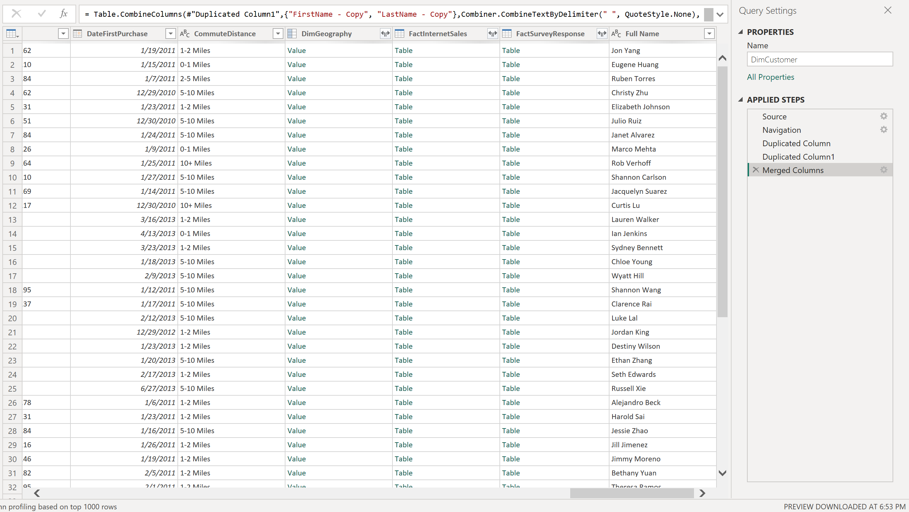

4. 1-2. I deduplicated two columns and then merged them to get Full Name

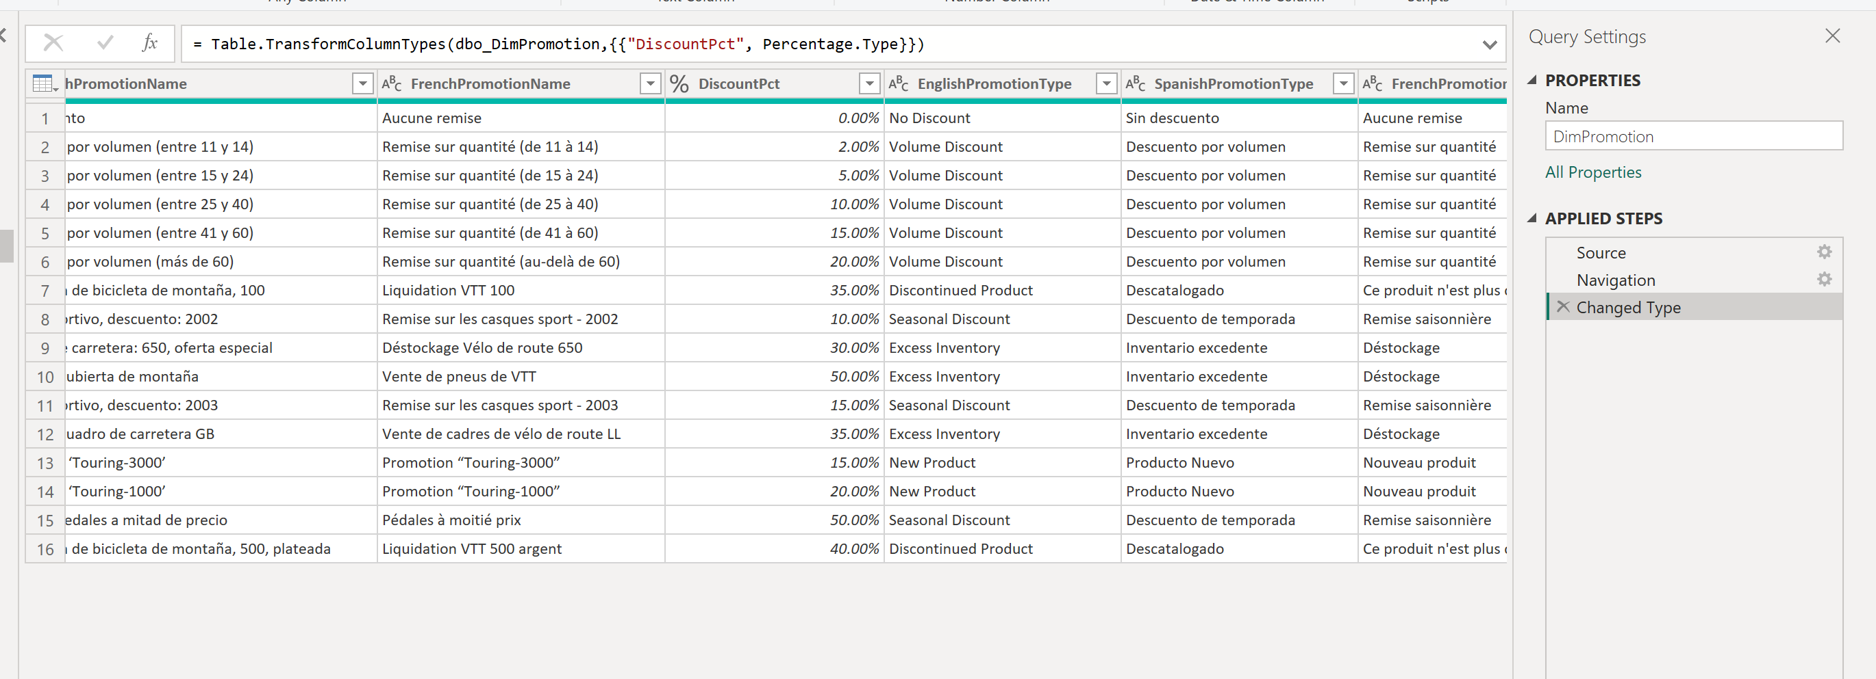

3. I changed the type of the DiscountPct into percentage and as its visible it added & sign

4. 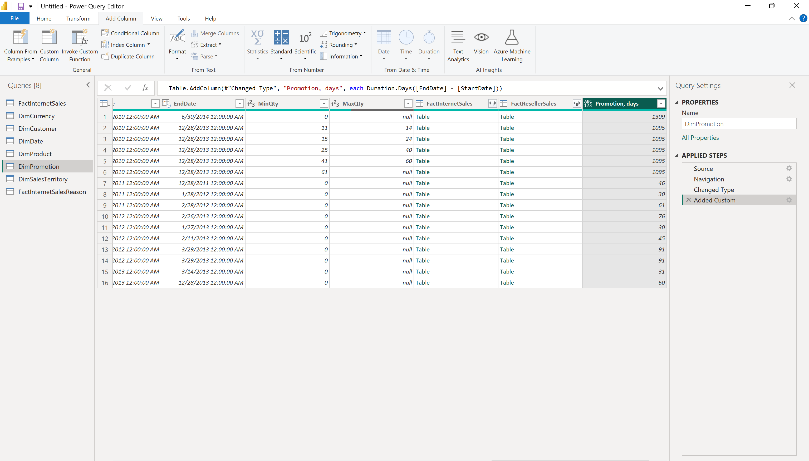

Add the column, promotion days. I did with custom tables.

4.3

Loading new tables and selecting view option

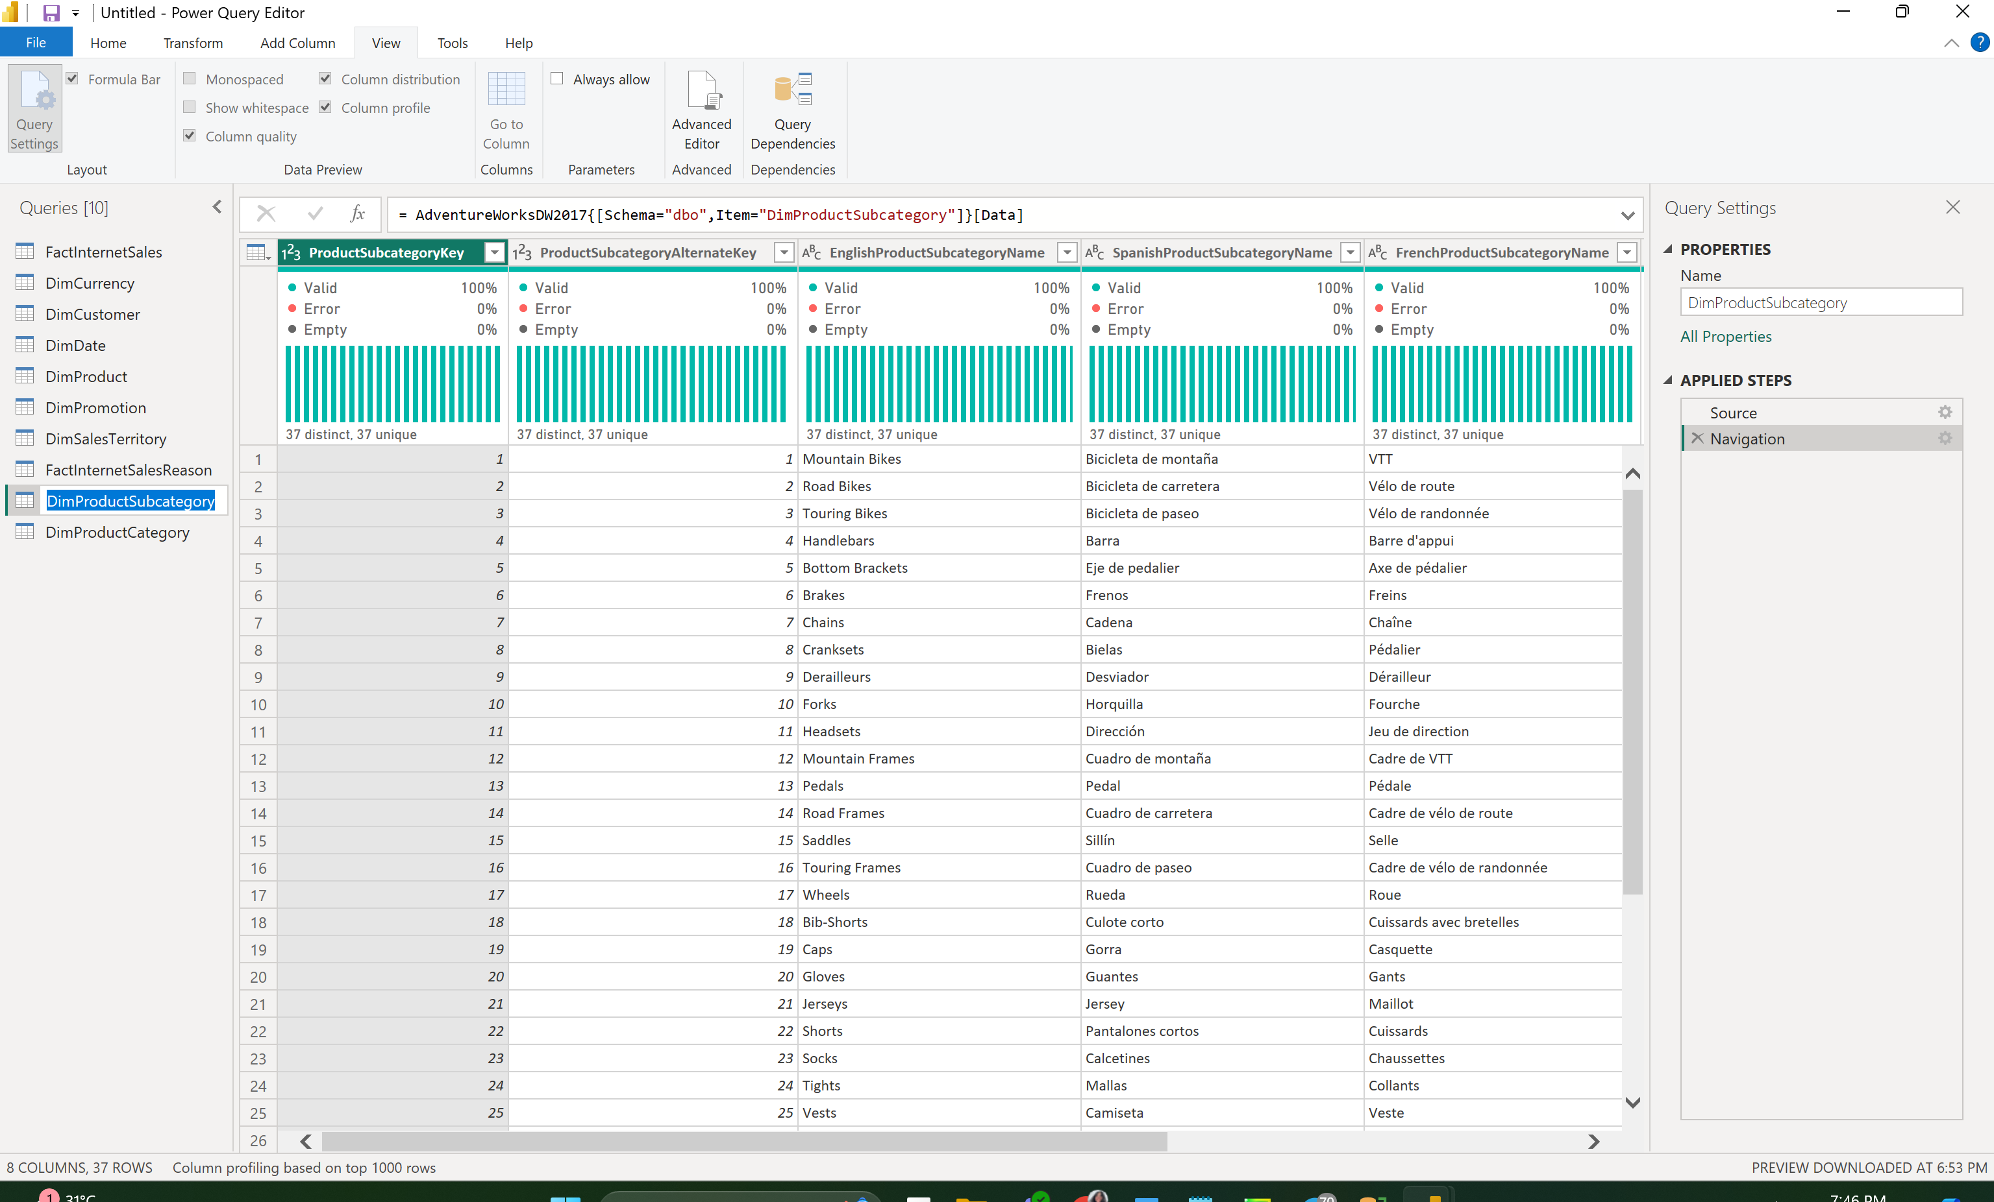

4.5

1. Creating order year

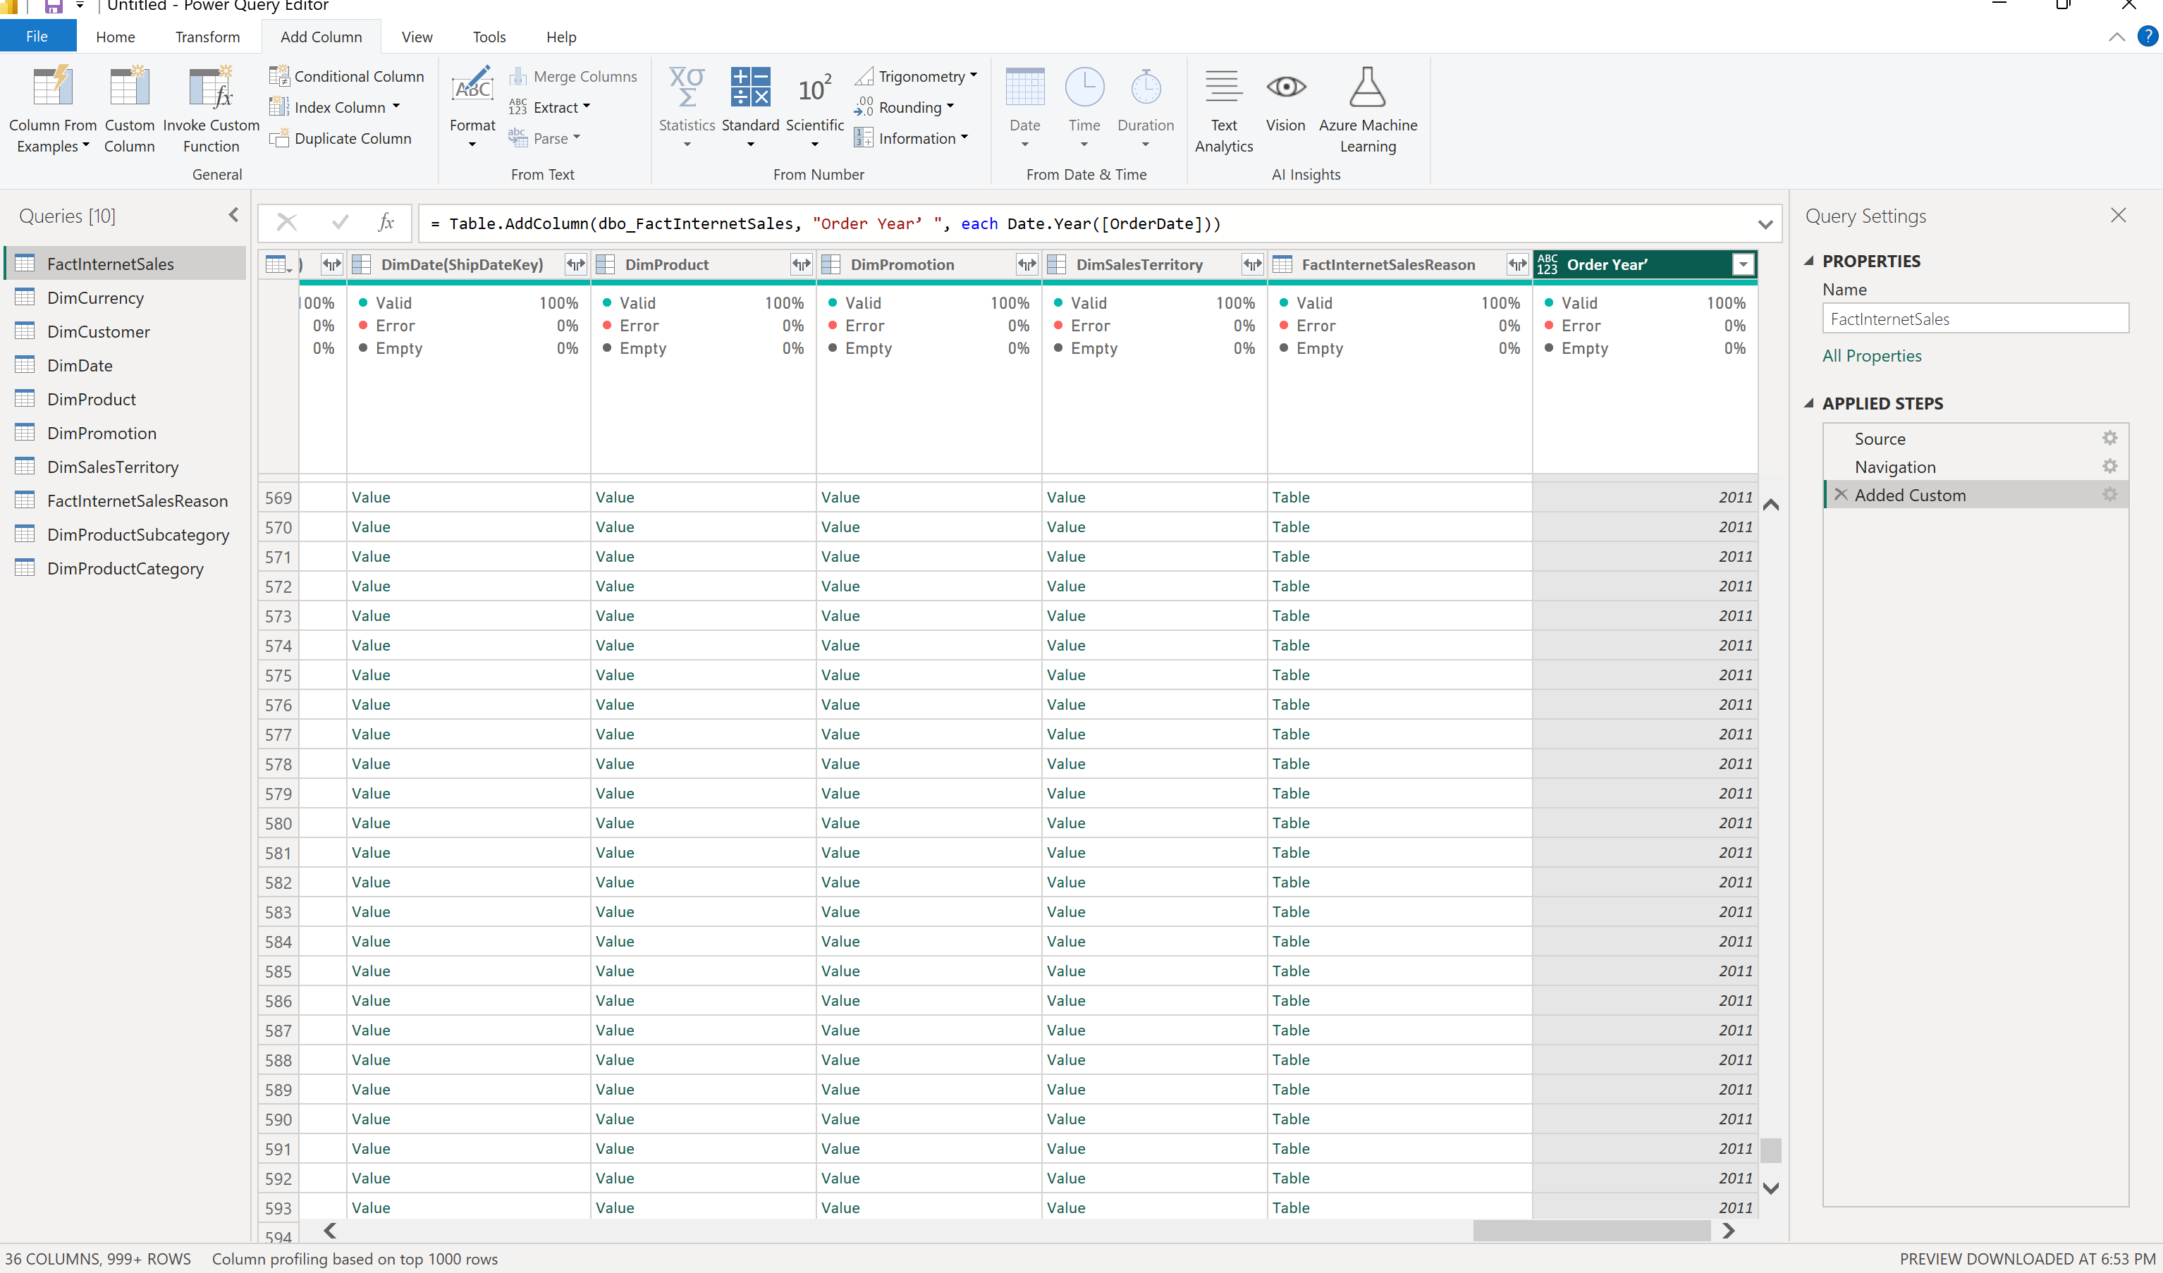

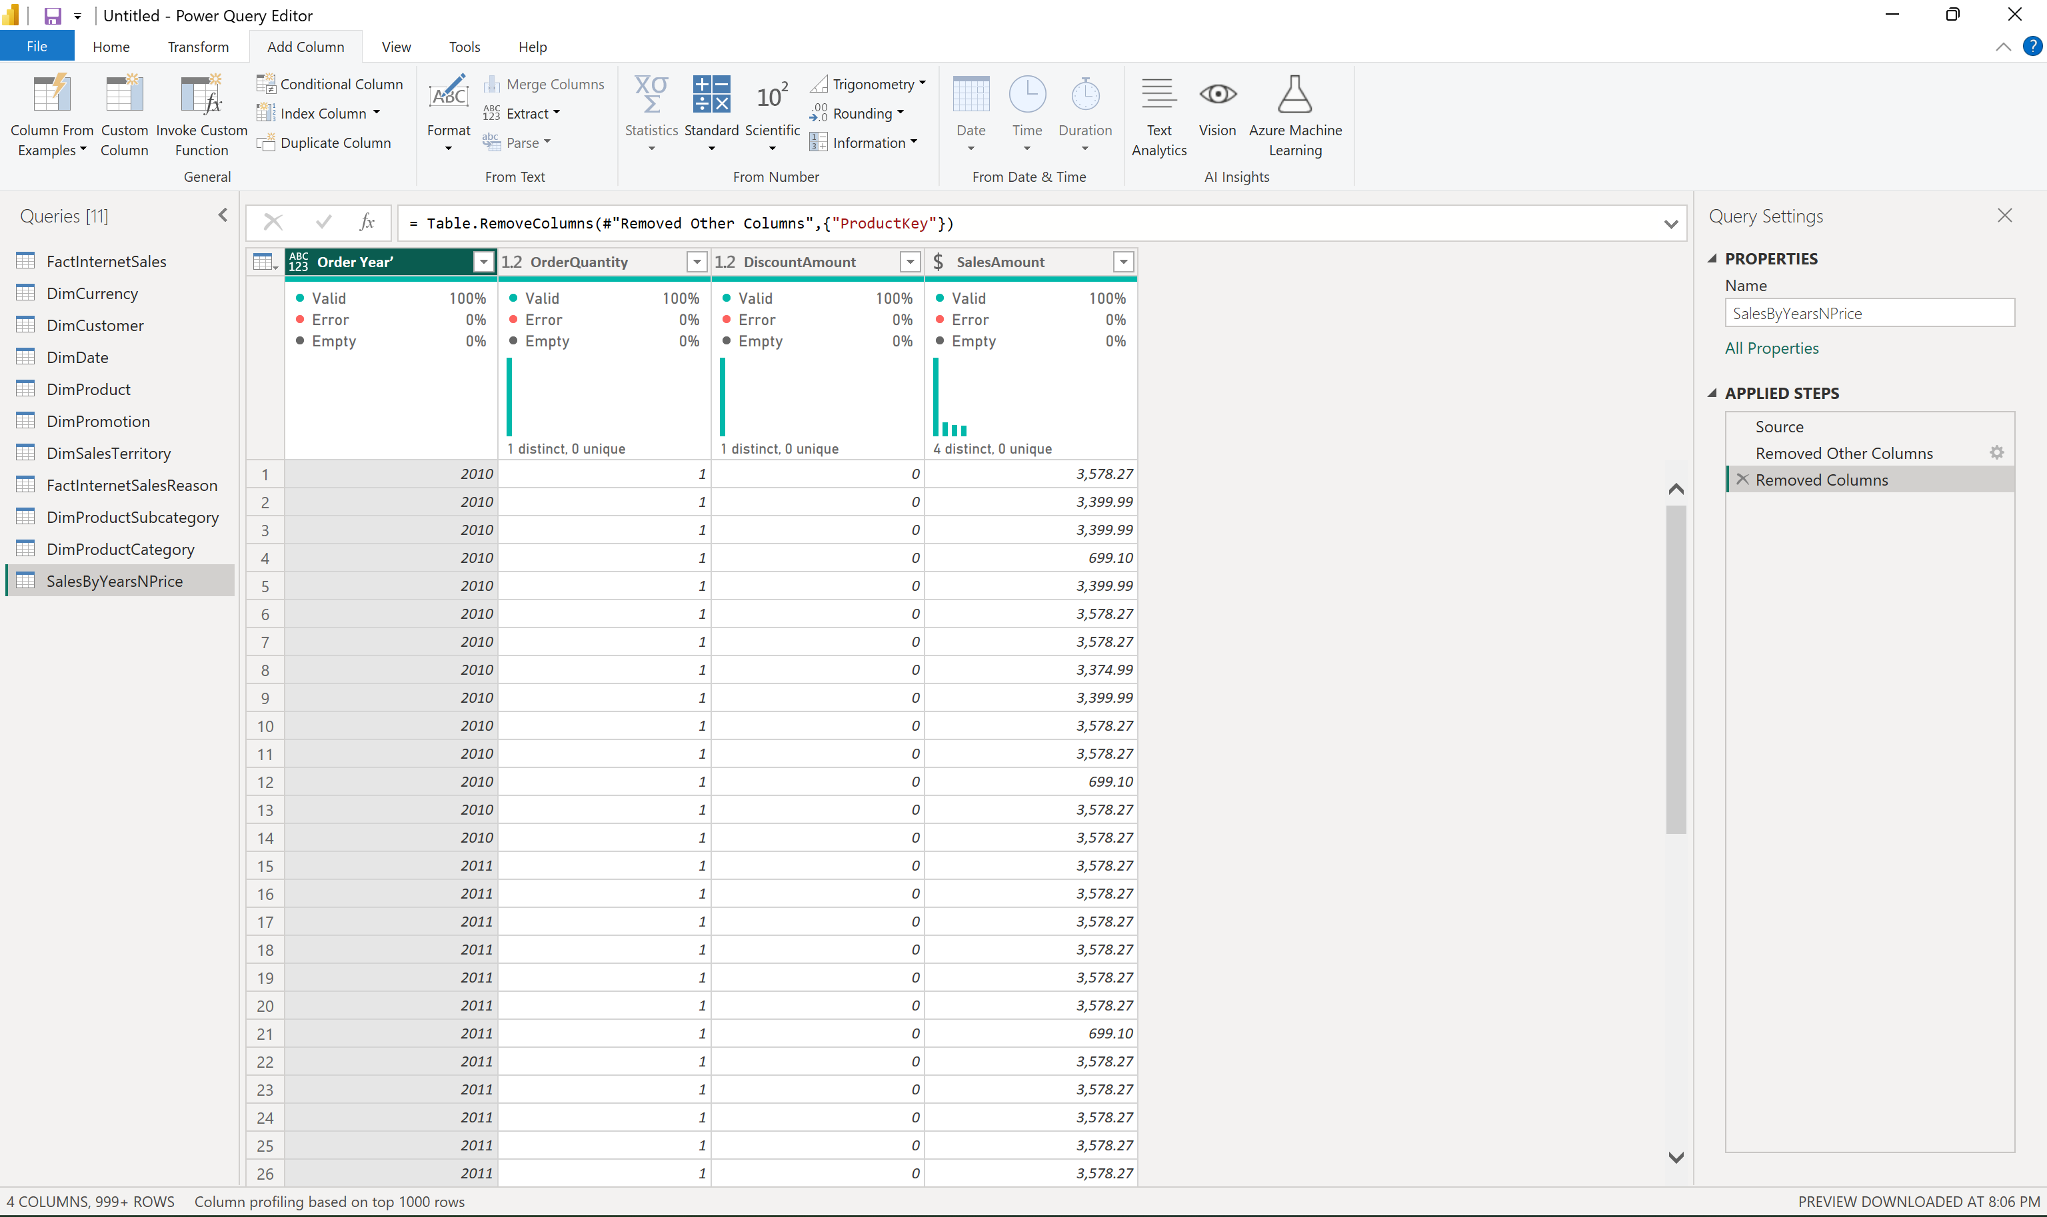 2. remove everything except those columns

3. pivoting

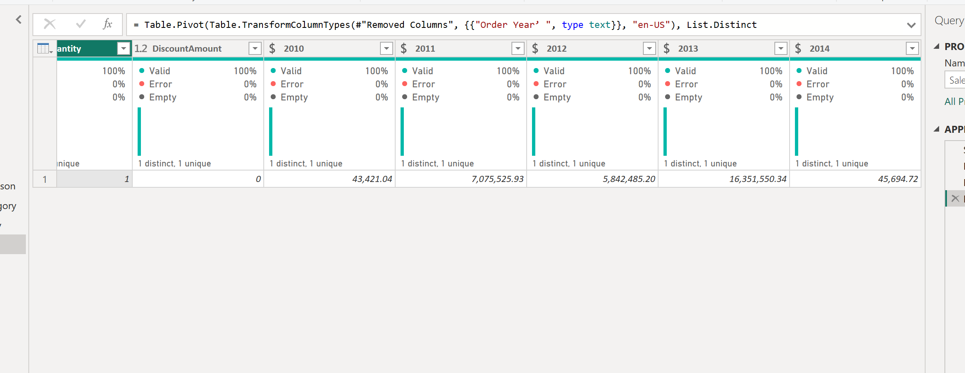

4.6

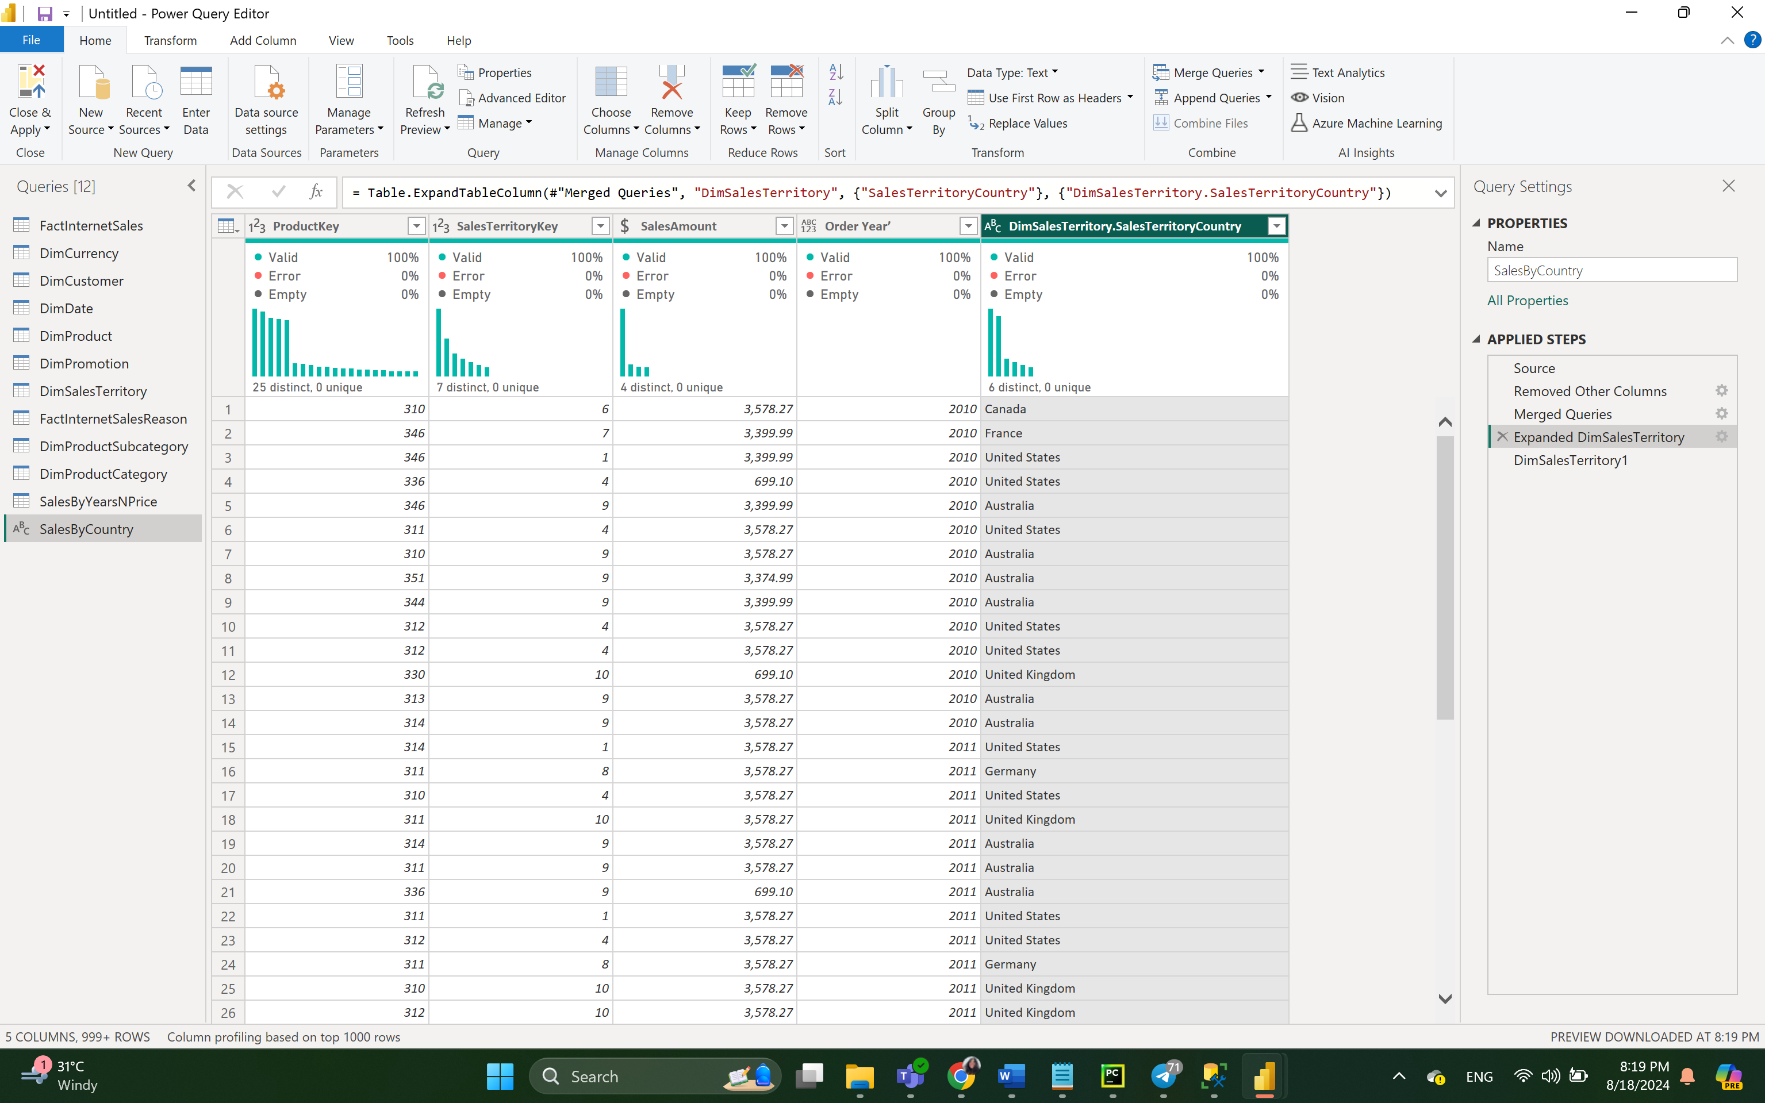

Sales territory country added

English product category name joined

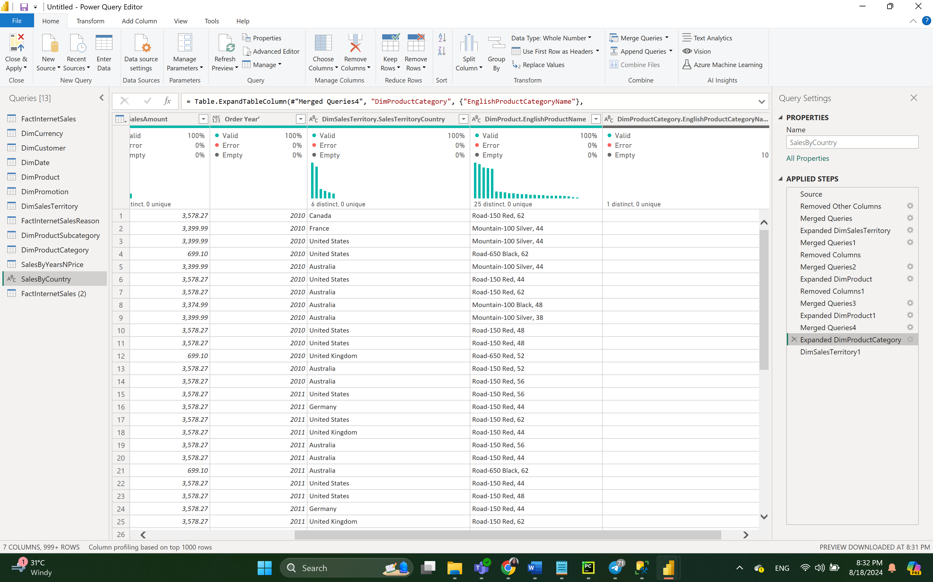

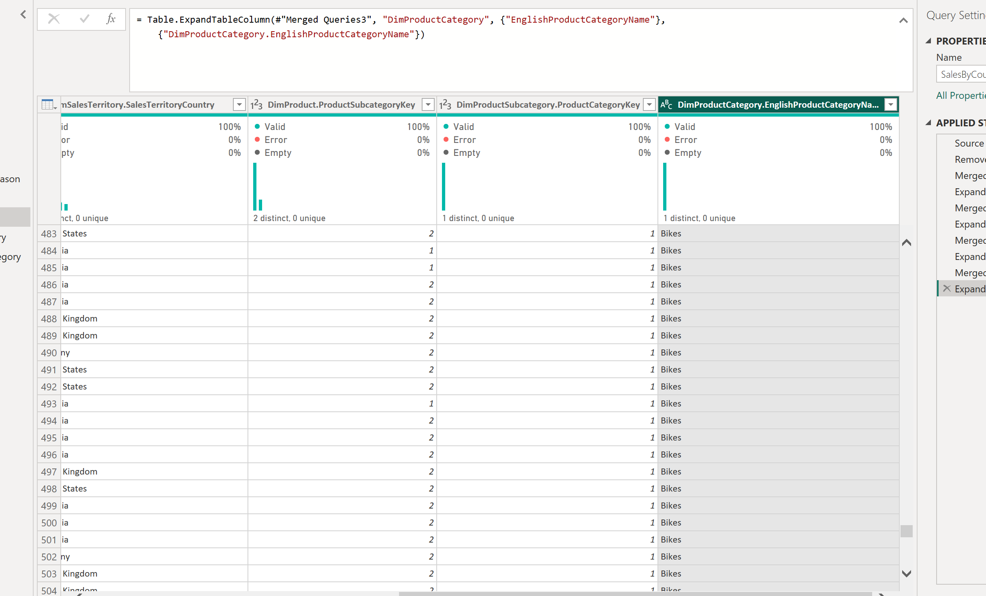

Joining first product on product key, then product subcategory , then from product subcategory I am joining to product category and after that getting the result. Of English product category name

4.7

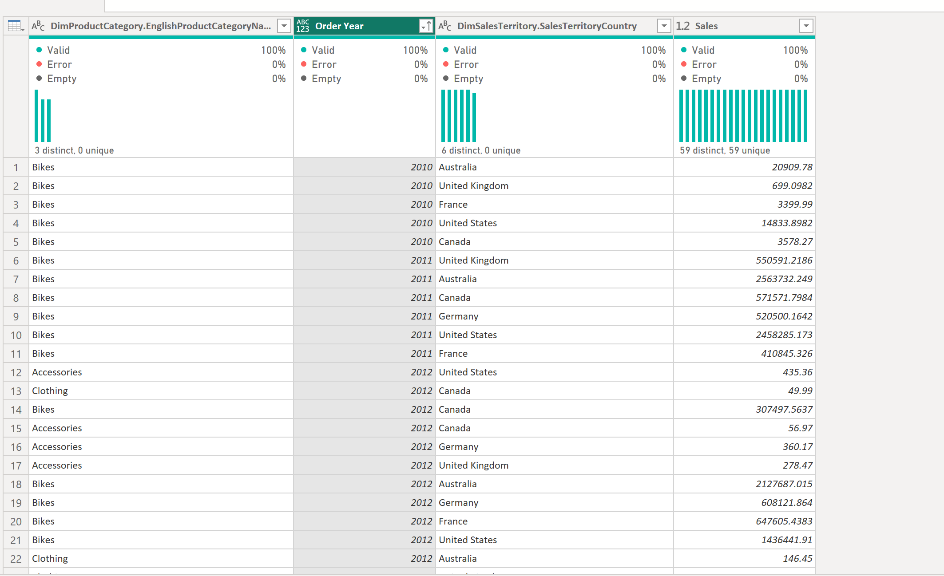

Grouping by English category name, order year and sales territory country and getting sales based on it.

Order by year asc.

4.9

Import Mode is generally faster for report interactions and allows more flexibility in modeling, but it has limitations on data size and the need for regular refreshes. In Import mode, Power BI copies the data from the data source into the Power BI file, which means all the data used in your reports is loaded into Power BI's internal data model. Since the data is already in-memory, report queries are typically faster because they do not need to go back to the original data source to fetch the data. All Power BI modeling features are available, such as complex DAX calculations, calculated tables, relationships, and hierarchies.

DirectQuery Mode offers real-time data without the need for refreshes and can handle large datasets, but may introduce performance challenges and has certain modeling limitations. DirectQuery does not store data in Power BI. Performance depends on the speed and efficiency of the underlying database. Some features like calculated tables and columns, complex DAX functions, and relationships with calculated columns are restricted or not supported. This is because every change triggers a query to the database, making complex calculations expensive in terms of time.

4.10

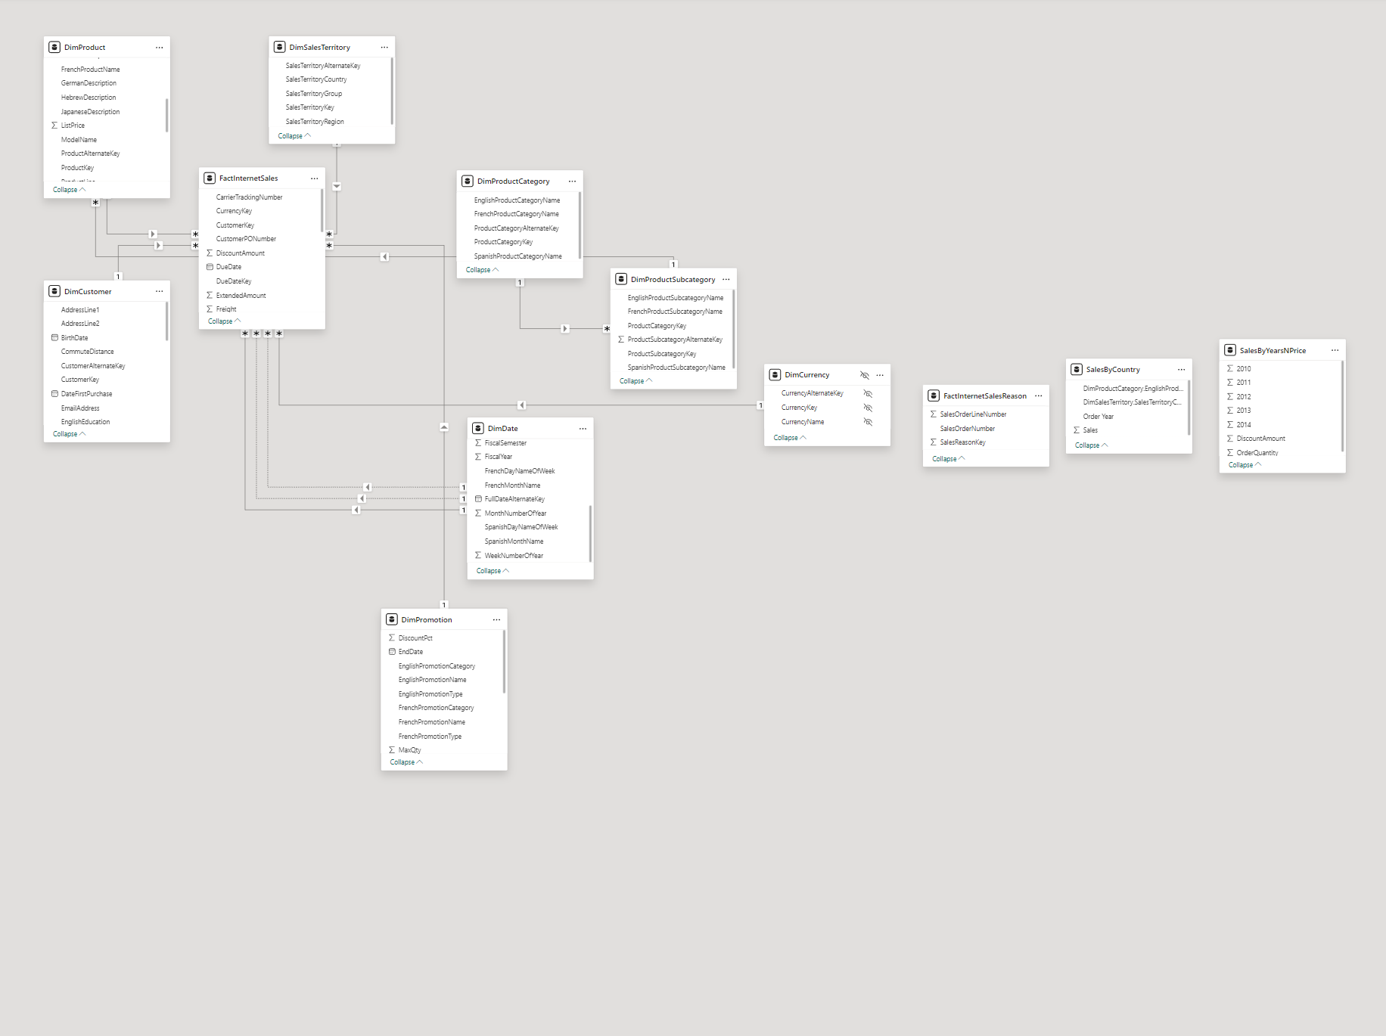

Cross filter direction is single. For all table mostly there is one to many relationship

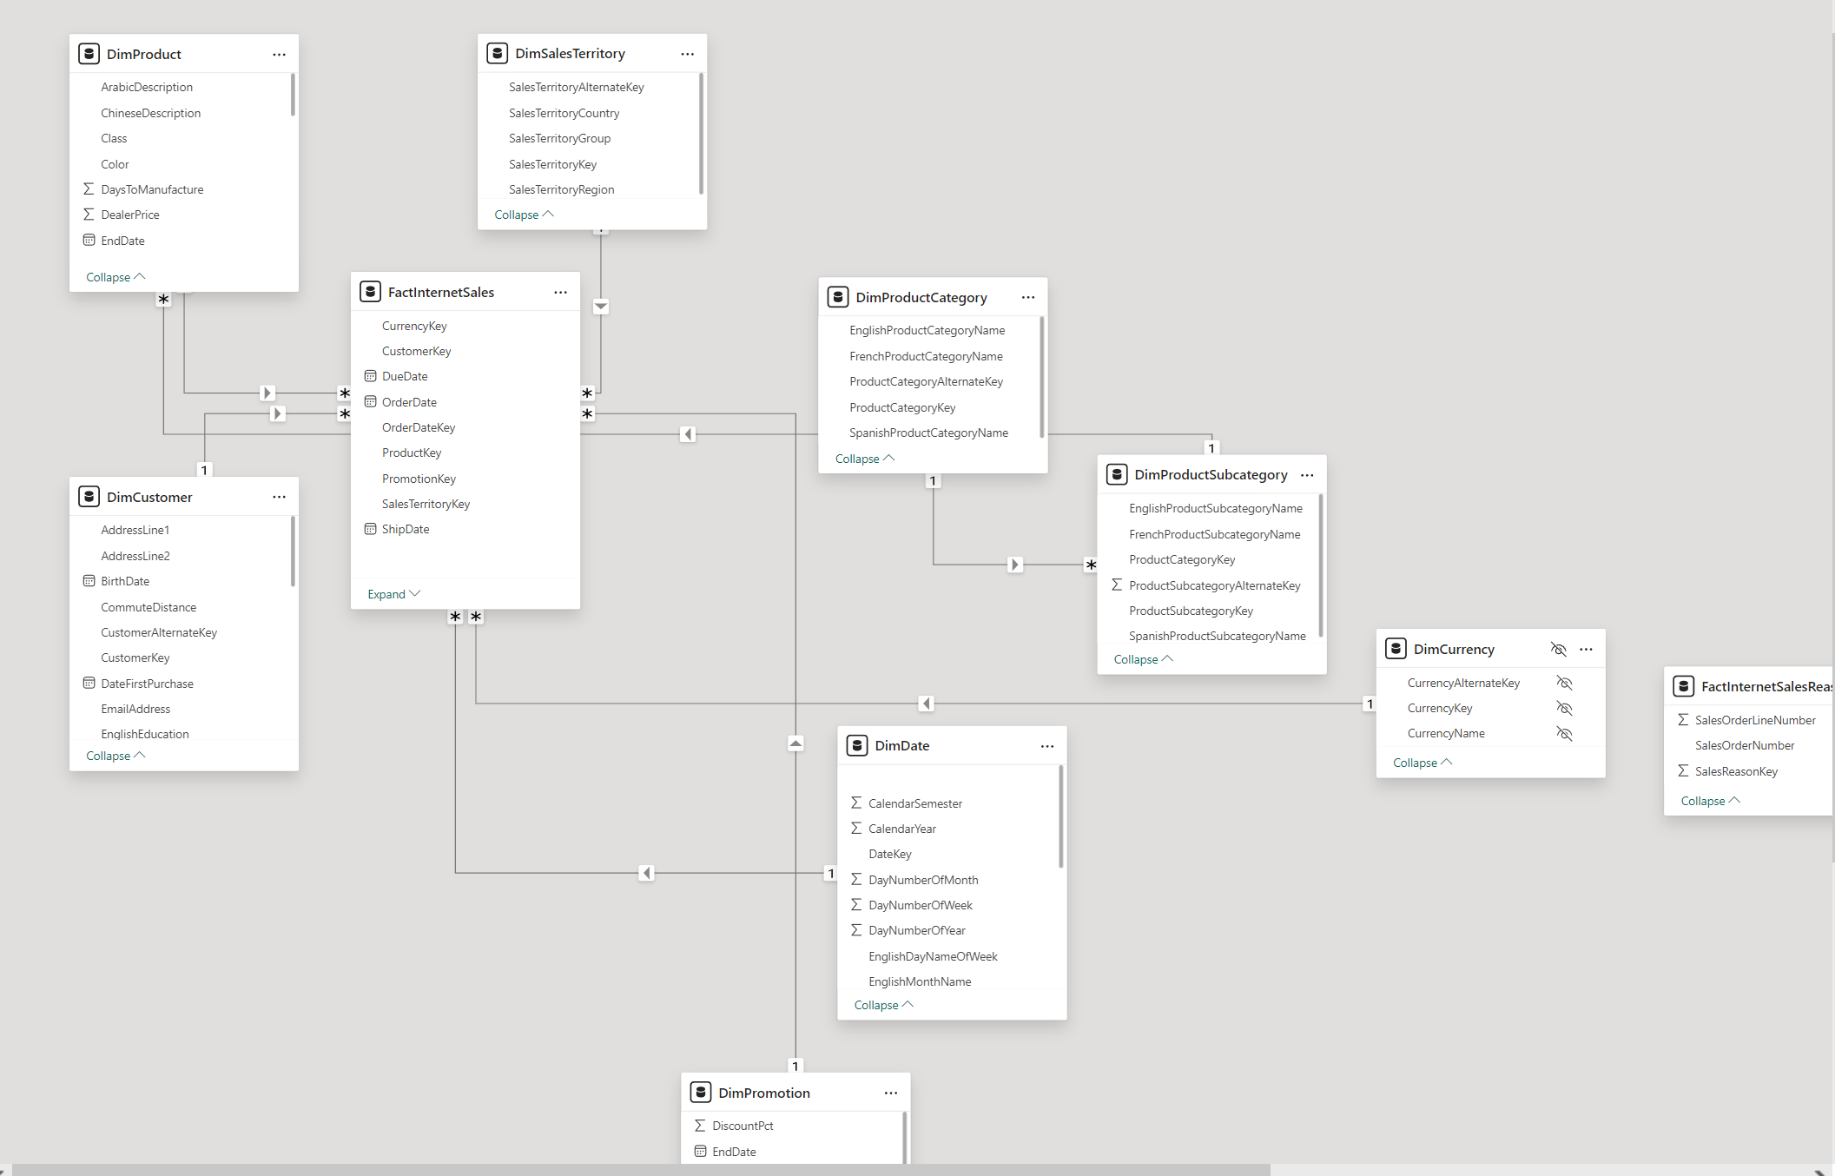

I made the necessary changes: deleted relations other than order date between dimdates and factinternetsales table. And made this relationship active. And this is the result.